Modesto Junior College Associated Students

Prepared by: MJC Business Services
Revised on 08/06/14 File Name: Accounting Manual-Final.docx

Purchase Order Procedures

Accounts Payable

This material is not all inclusive but is intended to cover those policies and procedures which should be referenced on a more than occasional basis by a significant number of the Associated Student activities. If you cannot find policies and procedures in this section that relate to your situation or if you need assistance, please contact the ASMJC Office.

MJC Business Services, assuming appropriate documentation has been submitted, is responsible for accurate and timely payment of all purchase orders for the Associated Students of Modesto Junior College.
- All completed ASMJC purchase orders are due at the Business Office on Tuesdays by noon.
- Supporting documentation (see Page 17) must be securely fastened to the purchase order.
- Reimbursements must include an original detailed receipt and proof of payment such as a paid invoice or credit card statement.
- Purchase orders without sufficient supporting documents will be returned, unless they were not submitted to the Business Service on time, to the ASMJC by 2:00p.m on Wednesdays.
- Checks, unless otherwise indicated, will be printed and mailed on Thursdays.
- Checks may also be picked up by the vendor at Business Services on Thursdays after 3:00 p.m.
Purchase Order Processing Procedures
    - Date: Enter the current date.
    - Vendor: Enter the name of individual/company/organization to whom the check is payable to.
    - Address: A complete mailing address must be provided.
    - To Be Picked-Up By: Indicate special mailing instructions.
    - Item/Part Number (if applicable).
    - Description: Enter a description/purpose of the payment.
    - Quantity: Enter the number of items ordered for each description.
    - Unit Price: Enter the dollar amount per item.
    - Total: Enter the total dollar amount by multiplying the quantity of each item by the unit price.
    - Account Description: Enter the description of a Datatel account.
    - Account Number: Enter the account number that you will be using for this transaction (make sure the account has sufficient funds to complete the request).
    - Signatures: The Purchase Order Form must be signed by the following Individuals:
  - Club Advisor(if applicable)
B. ASMJC President/Designee
C. ASMJC Advisor (a designated certificated employee)/Club Advisor
D. Vice President of Student Services
13. Student Organization/Club Name: Provide the name of the student organization or club.
14. Contact Name: Provide the name of the person who is in charge of planning the event.
15. Contact Number: Provide the contact person’s telephone number.
16. Activity Sheet Number: If the payment is for the event that requires an Activity Sheet, the number of the Activity Sheet must be provided.

NOTICE: All submitted purchase orders must be numbered by MJC Business Services. Purchase orders numbered by any other source will be considered fraudulent and will NOT be valid. This will delay the payment. 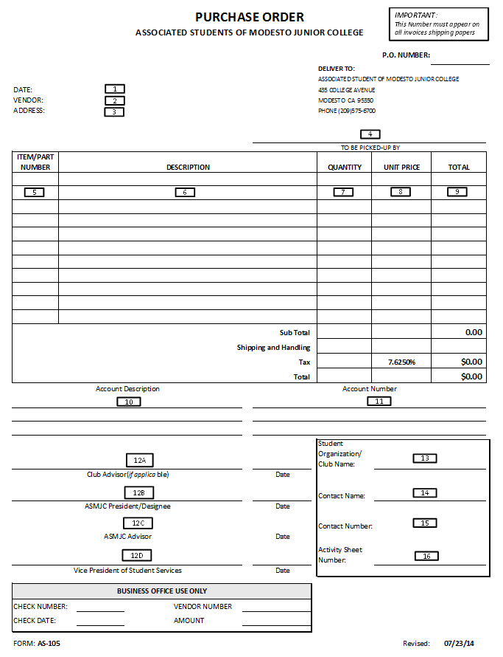
Required Documents for Processing an ASMJC Purchase Order
General Paperwork (required for all forms of payments):
- An ASMJC Purchase Order Form
- Copy of Minutes, including budget breakdown.
- An original Invoice(if applicable)
- An Event Itinerary, Event Program/Event Flyer (if applicable)
- A completed IRS Form W9
- ASMJC Contract (signed by the Executive Vice Chancellor, Fiscal Services)
- An Estimate/Quote
Payment to Vendors with a Federal Tax ID Number:
The majority of ASMJC payments are made to vendors with a Federal Tax ID Number. If Business Services does not recognize the name of the vendor on the purchase order, even if they have a Federal Tax ID Number, a request will be made for an IRS Form W9 ( http://www.irs.gov/pub/irs-pdf/fw9.pdf ) to be completed and submitted prior to payment. The following required documentation must be submitted prior to payment: Items 1- 4 above.
Payment to Vendors without a Federal Tax ID Number:

Pursuant to U.S. Treasury Regulations, the District is required to obtain the name and corresponding taxpayer identification number (TIN) for certain vendors that are providing services/materials to the District. Each year, the Internal Revenue Service (IRS) requires the District to file Forms 1099MISC, Miscellaneous Income, to report vendors who earn in access of $600 per calendar year (See IRS Instruction for Form 1099MISC on Box 7 Nonemployee Compensation-http://www.irs.gov/instructions/i1099msc/ar02.html#d0e900). The IRS imposes penalties on the District for each name and/or TIN reported on Form 1099MISC that does not match the information contained in the IRS database. Vendors without a Federal Tax ID Number are required to provide the following documentation prior to payment: Items 1- 5 above.
Payment for Services Performed by Vendors without a Federal Tax ID Number:
Per Internal Revenue Service (IRS) regulations, the District is required to report individuals who performed services over $600 per calendar year to the IRS using Form 1099MISC (See IRS Instruction for Form 1099MISC on Box 7 Nonemployee Compensation-http://www.irs.gov/instructions/i1099msc/ar02.html#d0e900). These individuals need to submit a completed copy of IRS Form W9 (( http://www.irs.gov/pub/irs-pdf/fw9.pdf) prior to the payment. ASMJC is required to provide the following documentations prior to payment: Items 1- 6 above.
Purchase Order Requests (for vendors who accept a P.O. prior to the payment):
In many cases, vendors will accept a purchase order. These purchase orders guarantee payment to the vendor, so they can ship the merchandise with peace of mind, knowing that payment will be made to them. Some of these purchase orders are submitted on a yearly basis (example: Costco, MJC Bookstore, etc.) and some are submitted on a case-by-case basis, such as when the Student Government/Clubs request District Transportation. The following documentation must be submitted to MJC Business Services for a Purchase Order to be issued. (No other additional documentation is needed to process payment to the vendor with the other than an original INVOICE.) Items 1, 2, 4, 7 Plus 3 (at the later date when the original invoice has been received) above.

