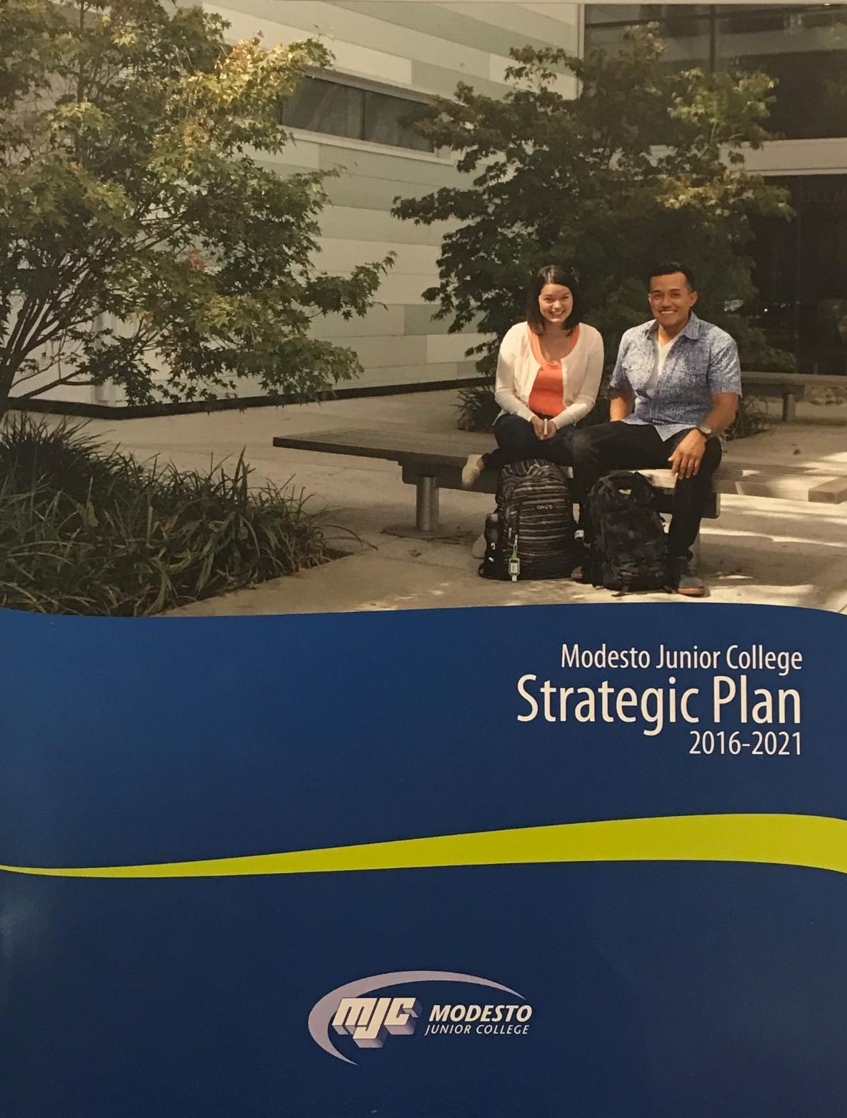
June 2017
CTE Program Review
Ag Environmental Science

Modesto Junior College

CTE Program Review
June 2017
Contents
Program Overview 2
Program Overview 2
Response and follow-up to previous program reviews 2
The Mission of Modesto Junior College 4
Student Achievement and Completion 5
College Goal for Student Achievement 5
Success 5
Conferred Award Trends 6
Student Learning Outcomes 7
Student Learning and Outcomes Assessment 7
Curriculum and Course Offerings Analysis 9
Curriculum Analysis 9
Course Time, Location and Modality Analysis 10
Program Analysis 11
Program Personnel 11
Faculty Assignments 11
Departmental Productivity Measurements 12
Long Term Planning and Resource Needs 13
Long Term Planning 13
Resource Request and Action Plan 13
Evaluation of Previous Resource Allocations 14
Career Technical Education Questions 15
How many students did you serve in the last two academic years? 15
What kinds of students are you serving? 15
What percentage of your students are persisting? Consider within the program and within the college. 15
Are students getting and keeping jobs? 15
What percentage of students are attaining a living wage? 15
Appendix 16
Optional Questions 16
Review Process Feedback 16
Executive Summary 17

Program Overview
Instructions
Supplemental information, links to previous reviews, and dashboards can be accessed from the review, please ensure your pop-up blocker is turned off, or use Ctrl-Click to bypass it.
Please review each question below, following the prompts and links given in the help text. Additional help, and a list of frequently asked questions is available on the Program Review Instructions page.

Program Overview
Please list program awards that are under this department according to the college catalog. Next to each program award listed;
- Please denote if it should be included here, or should be listed elsewhere.
- Answer yes or no, if the program has external regulations
- Additional lines, if needed, may be added by typing the tab key while in the last cell
- Any additional notes can be added in the box below the table
[addl help]
Program Awards | Include in Review (yes/no) | External Regulations (yes/no)
Environmental Science (degree)  Environmental Science (certificate) | Yes  Yes | No  No

Response and follow-up to previous program reviews
On the Curricunet website, please locate your department and the previous program review. After reviewing, please complete the following questions;
Briefly describe the activities and accomplishments of the department since the last program review.
This is a new program that is limited on data beyond the single course offering.

The Ag Environmental Science major is the newest addition to the Agriculture department of the department. The Ag Environmental Science program is similar to the old Natural Resource program which was closed years ago. The difference is this program is focusing on sustainability issue rather than forestry. Even with the closing of the Natural Resource program the Introduction to Environmental Science 108 class has maintained enrollment in course offerings even though overall college enrollment has declined. The Environmental Science program was recently awarded a Strong Workforce grant. This grant is to develop a Permaculture area for students and community to learn about sustainable practices.

Environmental students have the availability to participate in a wide variety of leadership development activities including: MJC Field Day Agronomy contest, Regional and Sectional Public Speaking competitions, keeping records and assisting with the financial side of Natural Resource Committee. Students compete at the CAL Competitions each Spring Semester in the area of Agriculture Sales Presentations and are very successful bringing home first place awards.

2017/2018 MJC Catalog Addendum

Associates Degree: Agricultural Environmental Science ( Formerly Forestry)

Certificate of Achievement: Agricultural Environmental Science ( Formerly Forestry)

The Mission of Modesto Junior College
MJC is committed to transforming lives through programs and services informed by the latest scholarship of teaching and learning. We provide a dynamic, innovative, undergraduate educational environment for the ever-changing populations and workforce needs of our regional community. We facilitate lifelong learning through the development of intellect, creativity, character, and abilities that shape students into thoughtful, culturally aware, engaged citizens.
Provide a brief overview of the program and how it contributes to accomplishing the Mission of Modesto Junior College. (Overview Suggestions: How consistent is the program with the institutional mission, vision, core values and/or goals? How are aspects of the institutional mission addressed within the program? Is the program critical to the pursuit of the institutional mission?)
The primary function of the Environmental Science program is to introduce students to the primary concepts encompassed by Environmental Science including: Agronomy, CA Native Plants, Evasive Species, Air Quality, Water, Sustainability, Natural Resources, and Energy. The program also meets many transfer requirements for students who wish to pursue a degree at a four-year university.

In keeping with the Mission of the YCCD and Modesto Junior College the primary goal of the Environmental Science degree programs is to provide students with skills enabling them to make logical and sound business decisions given the global nature of agriculture today. Through local industry contacts and business partnerships students are provided with innovative learning opportunities. Agriculture is a diverse and powerful driving force in the Central Valley and the MJC Environmental Science program is student-centered and devoted to providing every student with a solid educational foundation.

Student Achievement and Completion

College Goal for Student Achievement
Increase Scorecard Completion Rate for Degree and Transfer
The College has a primary aspirational goal of increasing the Completion rate from 43% to 53% on the CCCCO Scorecard Completion Rate for Degree and Transfer [view] by 2022. The completion rates in the Scorecard refers to the percentage of degree, certificate and/or transfer-seeking students tracked for six years who completed a degree, certificate, or transfer-related outcomes (60 transfer units).
As you answer the questions below, please consider how your program is helping the college complete this aspirational goal of increasing the MJC Degree, Certificate, and Transfer Completion rate by 10% on the CCCCO Scorecard by 2022.

Success
The following questions refer to data from the Department Success Rates Dashboard. Use the filters to examine both departmental and course level data. Charts will be included for the record by Research and Planning once the review is submitted.
Locate your department success rates on the Success Rate Data Dashboard and consider your department success rates trends over time, especially the last two years. Also, consider the data detailing the variance of success rate of courses across sections. Are these rates what you expected? Are there any large gaps? Is there anything surprising about the data? What do you see in the data?
There is really only one class to use with data. But in looking at the success rate of the Environmental Science Class/Program it has hovered in the 73.5% range with ups and downs between spring and fall for the past 5 years. The fill rate has declined somewhat over the past five years also. Both of these trends are representative of the department. This is interesting as it would seem that as fill rates decline, success rates would increase but that is not the case with the data presented. The most recent data for spring 2017 show an increase in success rates. The instructors have not remained relatively the same over the past 5 years so perhaps the student population success is reflected in perhaps a variety of teaching styles. The one current course offering has 5 sections this semester with much of the class being found on Canvas and all taught by one instructor for the first time in the last five years. So it will be interesting to look at the data in the future.

What is your set goal for success? Do your department and individual course rates meet this goal?
Continued increase by a minimum of 1% per year would be an achievable goal for the department as a whole. The Environmental Science is setting a goal of 2%.

If your rates for success are lower than your goals, what are your plans to improve them?
If are rates of success are lower than our goals we will evaluate programs individually, look at the delivery methods, consult our advisory committee, and work with instructors to collect accurate data.

Locate your department equity rates on the Success Rate Data Dashboard (by pressing on the equity tab). Examine these rates, disaggregated by ethnicity and gender, over the last two years. If there are differences in success across groups, how do you plan on addressing issues of student equity? In other words, how do you plan on closing achievement gaps across student populations?
The large majority of our students are Hispanic (over 50%) 65% success rate, with a smaller majority being White nH (around 45%) 73% success rate. The success rate in this demographic is lower than the smaller majority by a difference of about 8%. District wide Hispanic success rate is 66% and White nH success rate is at 72%. So this data suggests that the single class is running really close to school wide success rates. The success rate in the Asian group is the highest for the next largest group represented with 74% which only represents 26 students and this is very close to school wide success rates. This class being added to a program as well as being a transferable class will help draw students into a program they can connect with as well as have a positive effect on success rates. One way to close achievement gaps would be to identify the specific students representing these groups and reach out to them to provide additional assistance. Perhaps this is where the “Student Success Coaches” could actually make a difference with these targeted individuals.

If distance education is offered, consider any gaps between distance education and face-to-face courses. Do these rates differ? If so, how do you plan on closing the achievement gaps between distance education and face-to-face courses?
We have increased the numbers of sections for hybrid courses over the past few years however, the primary method of teaching is face-to-face. We are looking at expanding this area more.

Conferred Award Trends
Review the Program Awards Dashboard, using the drop-down filters to focus the analysis on your department. Starting with identifying the year, please supply degrees and certificates awarded. These charts will be attached by Research and Planning before being posted publicly.
What is your set goal for degrees and certificates awarded? Do your rates meet this goal?
The Environmental Science Program has had no degrees or certificates awarded yet as it is a new program. 10 by Summer 2019, 20 by Summer .2020

If your rates for degrees and certificates awarded are lower than your goals, what are your plans to improve them?
Advising students on how to apply for awards and which courses will allow them to obtain multiple awards.

Student Learning Outcomes
Instructions
This section of the Program Review measures student learning.
PLO / GELO / ILO Outcomes
To ease in analysis, trending charts have been created by Research and Planning on the Learning Outcomes Dashboard website. Using these charts, you can identify your current success rates in student achievement towards the outcomes. Considering your current outcome success rates, and previous semester, set a department aspirational goal, and examine what your outcome success rates are currently. Later you will be asked to outline a plan to achieve this threshold, but for now, simply supply the Goal % and Current % for each level.
Note: If the dashboards do not show your Learning Outcomes, please ensure that they have been mapped in eLumen. Each course will need to be mapped to each applicable PLO, GELO, and ILO. The Outcome Assessment Workgroup has created a web page detailing the work already done -> PLO, ILO, and GELO Assessment grids. For additional assistance, review the Course Learning Outcome Assessment web pages, or contact Nita Gopal at gopaln@mjc.edu.

Student Learning and Outcomes Assessment
Please review your Learning Outcomes data located on the MJC Student Learning Outcomes Assessment website and below, in regards to any applicable Program, Institutional, and General Education Learning Outcomes.
For each ILO that your course learning outcomes inform, you will find your overall rate. On the MJC Student Learning Outcomes Assessment website, you will also see that overall rate disaggregated across student populations; you can use this information to understand how different student populations are learning in your courses.
After you have examined your rates and disaggregated data, reflect on the data you encountered. Please address the program outcomes (PLO), general education outcomes GELO (if any), and institutional outcomes (ILO) in your analysis.

Program Learning Outcomes (PLO)
What is your set goal for PLO success? Do your overall rates meet this goal?
The goal is to continue to develop and increase PLO success and the success rates to meet this goal.

General Education Learning Outcomes (GELO)
If your program has General Education outcomes, what is your set goal for GELO success? Do your overall rates meet this goal?
Not applicable

Institutional Learning Outcomes (ILO)
What is your set goal for ILO success? Do your overall rates meet this goal?
Not applicable.

Continuous Quality Improvement
If your rates for success for any PLOs, GELOs, and ILOs are lower than your goals, what are your plans to improve them?
The rates will meet our goals through our department changes.

Equity and Success
Do your rates for your PLOs, GELOs, and ILOs vary across student populations? How you do you plan on addressing issues of equity? In other words, how do you plan on closing the learning gaps across student populations?
No program data.

Curriculum and Course Offerings Analysis

Curriculum Analysis
Courses that have not been reviewed, or not scheduled to be reviewed, are listed on the Curriculum Committee web pages. To aid in use, please view this filtered spreadsheet, using the drop down menus along the field headings, to view just your department. On opening the spreadsheet, click the Enable Editing and Enable content buttons that should appear across the top menu bar.
Considering those courses that have not been reviewed within the last five years, please address these below.
Provide your plans to bring courses into compliance with the 5-year cycle of review. If your department is compliant, please state that.
Provide your plans to either inactivate or teach each course not taught in the last two years.
The plan is to re-activate and teach two past classes including Ca Water 110, Sus Ag 150 by summer 2018. The program is looking to develop new classes in partnership with local agencies.

Does the College Catalog accurately display the descriptions and requirements of all the courses and educational awards (degrees/certificates) overseen by this program? If not, please describe your plans to correct.
Yes, the catalog is accurate and the catalog addendum.

Are there plans for new courses or educational awards (degrees/certificates) in this program? If so, please describe the new course(s) or award(s) you intend to create.
The next area of expansion will look towards certificates in wastewater and recycled water. Each will include 3-6 classes in each respective area.

What needs or rationale support this action, and when do you expect to submit these items to the Curriculum Committee?
We have a growing population of humans, a need to treat our wastewater, and public demand for safe water.

Course Time, Location and Modality Analysis
Please follow this link and review the Course Attributes in regards to when, where, and in which method the courses in this program are taught. Use the filters to focus the report on your department. Then answer the following questions.
Location/Times/Modality Trend Analysis:
Consider and analyze your location, time, and modality trends. Discuss any program plans that address more efficient and beneficial location, modality and/or time of day trends.
Environmental Science courses are taught primarily in the morning in a face-to-face format. The main course Environmental Science is taught as a face to face, the other classes to be added will also be face to face. 5 section are currently being taught with night classes being taught but there is always a need to address the need of more night classes. California Water will be offered as a Friday class in addition to an Environmental Science class being offered on a Friday gives more opportunities for students to have full schedules five days a week.

Program Analysis

Program Personnel
Please refer to the Department Faculty and Sections Dashboard to supply the names of faculty and adjuncts for the periods requested. Use the dashboard filters to focus on your individual department. Due to the complexity of payroll accounts and assignments, those listed may not match known individuals, please note any discrepancies.
Additional comments or narrative can be added below.
Faculty Name | Full-Time or Part-Time (adjunct) | Hire Date (optional)
Gravatt, Troy | FT | June 2014

Faculty Assignments
Please refer to the Department Faculty and Sections Dashboard to supply the number of faculty and adjuncts for the past two years of regular terms. Use the dashboard filters to focus on your individual department. Due to the complexity of payroll accounts and assignments, those listed may not match known individuals, please note any discrepancies. Please note that summer positions are all shown as adjunct due to payroll categories.
Enter figures for each term, to add additional rows, click in last cell on right and push tab on the keyboard.
Additional comments or narrative can be added below.

Term (Year Term, e.g. 2016) | # Sections Offered / Term | # Taught by FT Faculty | # Taught by Other Faculty | Program Fill Rate %
2015(Fall) | 4 | 4 | 0 | 100%
2016(Spring) | 4 | 4 | 1 | 85%
2016 (Summer) | 0 | 0 | 0 | N/A
2016 (Fall) | 3 | 3 | 0 | 103%
2017(Spring) | 3 | 3 | 0 | 97%

Departmental Productivity Measurements
If not pre-filled, please complete for two years the following table of indicators, as listed on top of the Productivity Dashboard. A picture of this dashboard will be supplied by Research and Planning. Please enter one term per line; to add an additional line, click in last cell and use the Tab key.
The space below is available for comments and narratives.
Term (e.g. 2016 Fall) | FTEF | FTES | FTES/FTEF | WSCH/FTEF
2015 Fall | 0.80 | 16.88 | 21.10 | 632.93
2016 Spring | 1.00 | 17.54 | 17.54 | 526.11
2016 Summer
2016 Fall | 1.00 | 20.91 | 20.91 | 627.42
2017 Spring | 0.80 | 16.14 | 20.18 | 605.39

Summer has not been offered. Looking to possibly offer Summer 2019.

Long Term Planning and Resource Needs

Long Term Planning
Provide any additional information that hasn't been addressed elsewhere in this program review, such as environmental scans for opportunities or threats to your program, or an analysis of important subgroups of the college population you serve.
View the Program Review Instructions page for reference and inspiration.
Taking into account the trends within this program and the college, describe what you realistically believe your program will look like in three to five years, including such things as staffing, facilities, enrollments, breadth and locations of offerings, etc.
The program will expand due to the nature of growth in Environmental Science in the local community. Stanislaus county will continue to lead the nation in agricultural production and modern agricultural trends will revolve more around management so the demand for students with skills in these areas will grow. Staffing in the department needs to be taken into consideration as the program grows to meet local needs. Replacement of retiring instructors, updates of facilities and the development of more online courses will require attention.
Enrollment in Environmental Science courses continues to expand with courses at or above capacity each semester. It's difficult to offer additional sections in the Environmental Science because there is only one instructor and the one is over 100% of a full load and plus has many obligations outside the classroom, so taking on extra sections is very difficult. The degree program is new as this program continues to experience solid enrollment and full classes, the use of equipment such as the computer lab, the buses for field trips and research areas in general needs to be maintained. . Plans for expansion, update, and replacement of the equipment needs to be taken into consideration.
Over the next five years this program would like to add an instructor to be able to offer more class options. Add the addition of the Grayson property for research and development. These two items will help establish this program as a leader in Environmental Science.

Resource Request and Action Plan
Priority | Name | Resource Type | Estimated Cost | Objective
1 | Grayson Property | Land | $0K | District owned
2 | Release Time | Personal - Certificated | $25K | Meeting load requirements without going over and teaching additional classes takes away from the development of any area. So by adding three years of release time that decreases over the three years would allow adequate development time. 15%, 10%, & 5%
3 | Ground Work | Services – Laser leveling | 15K | Minimal amount of early development.
4 | Well | Equipment | $70K | No irrigation exists
5 | Solar System | Equipment | $75K | Power to run well plus off-set energy costs over time.
6 | Irrigation | Equipment | $70K | Sub drip, and flood will allow research into
7 | Environmental Instructional Technician | Personal - Classified | $50K | This would allow the lab facilities and equipment to be more effectively and efficiently utilized and it would promote better maintenance and care of the existing equipment.
8 | Heavy duty pick-up | Equipment | $60K | Move equipment to and from facilities
9 | Flatbed trailer | Equipment | $10K | Haul equipment
10 | Environmental Science Instructor | Personal - Certificated | $70K | Expansion of classes and research facilities in an ever expanding field will draw more students to fill the classes as a result more instructors will be needed.
11 | Equipment | Equipment - rental | 10K | Rather than purchase or transport from the other ranches, John Deere and N&S tractor are relatively close. Both offer rental programs.
12 | Plant Material | Consumable – Seed, plants | $25K | Hedge row, and field cover
13 | Fence | Equipment | $26K | East campus fence project to expand and improve safety
14
15
16
17
18
19
20

Evaluation of Previous Resource Allocations
Below is a list of resource allocations received in previous Program Reviews. Please evaluate the effectiveness of the resources utilized for your program. How did these resources help student success and completion? (https://www.mjc.edu/governance/rac/documents/ielmallocationsummary20142015.pdf)
The Evaluation / Measured Effectiveness can be typed in another program and pasted here, or typed directly in to the box below. The box will expand with additional text, and paragraphs (hard returns) can be added by using Ctrl+Enter.
Resource Allocated | PR Year | Evaluation / Measured Effectiveness
N/A | New program | New Program
Strong Work Force Grant | 2017-2020 | Development of Permaculture lab, still under development.

Career Technical Education Questions
The following series of question focus on Career and Technical Education, and can be answered using the labor data from Cal-PASS Plus on Launchboard. You will need to create an account before accessing the Launchboard.

How many students did you serve in the last two academic years?
(See Program Snapshot Reports > Where are students taking courses in the region > student)
This is a new program with only one class. In 2015-16 329 students were served and 355 were served in 2016-17.

What kinds of students are you serving?
(See Program Snapshot Reports > Where are students taking courses in the region > Check Categories)
There are no similar programs in the region.

What percentage of your students are persisting? Consider within the program and within the college.
(See Program Snapshot Reports > Are students progressing the pathway? > Term-to-Term Retention and Persistence)
N/A

Are students getting and keeping jobs?
(See Program Snapshot Reports > Are students getting jobs?)
N/A

What percentage of students are attaining a living wage?
(See Program Snapshot Reports > Are Students Making Reasonable Wages? > Living Wages button)
N/A

Appendix

Optional Questions
Please consider providing answers to the following questions. While these are optional, they provide crucial information about your equity efforts, training, classified professional support, and recruitment.
What strategies do you use to recruit, support and retain students from disproportionately impacted groups?
Social media will be a focus of future recruitment activities.

Does your division (or program) provide any training/mentoring for faculty to support the success of students at risk of academic failure?
We do have faculty available to meet with students, many have an open door policy. One day a week we have a counselor in our program to help with advising. I’m not sure either of these or anything else addresses this question.

Is there a need for more classified professional support in your area, please describe this need. Indicate how it would support the college mission and college goals for success, and completion.
A career success coach should be in our program, it would help if they have some familiarity with Agriculture and the community.

What factors serve as barriers to recruiting active faculty to your program(s)?
N/A

Review Process Feedback
Please share any recommendations for improvements in the Program Review process, analysis, and questions. Your comments will become part of the permanent review record.
Why are instructors required to transfer data that is already existing in the campus wide report? It seems this information should already be on the program review, ready for us to analyze. Also the full time, part time facility names and information should already be on the report. Manually entering data and names takes time away from analysis and discussion.

Executive Summary
Provide an executive summary of the findings of this program review. Your audience will be your Division Program Review Group, the MJC Program Review Workgroup, and the various councils of MJC.
The Environmental Science Program is a new program that has strong connections with the agriculture industry not only within the state of California but also on a national level. This is a key attribute to effective, relevant instruction. The faculty continues to challenge students to examine potential careers in the industry and encourages students to investigate new and upcoming areas of importance in Environmental Science. This is a new program that continues to see industry wide growth and in keeping with the needs of humans this area is predicted to continue to grow. Areas of waste water and fresh water will see increased demands for people trained in these areas.

The development of the on campus area for sustainable Ag is the first step in developing expanded opportunities for students to experience hands-on opportunities to develop lifelong passion for environmental science. The next step of adding an area like the Grayson property would add the research step critical to challenge students to seek answers and work with Agriculture to develop solutions for future generations. Finally adding an instructor and tech position would expand opportunities for students. These position would be very beneficial for the program if this position could be expanded to a 100% full-time position.

Overall, the Environmental Science Program serves the students and the community in a very effective manner but with the concerns facing the human race much more could be offered.

