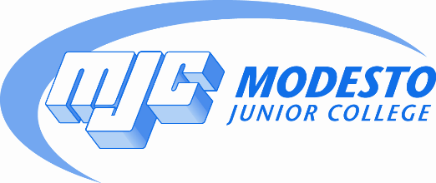

College Council
Agenda
January 23, 2017
Library Room 55 3:00 p.m.

- Call to Order

- Information and Discussion Items

- Accreditation Update
- Student Success and Equity Update
- Enrollment Update
- Educational Master Plan Introduction
- Reflections on Institute Day – Guided Pathways
- Resource Allocation/Facilities Update
- YCCD Board Policies
DRAFT 2015 – Student Member
DRAFT 3515 – Reporting of Crimes
DRAFT 4-8074 – Human Subject Research Protection
DRAFT 6305 - Reserves

- Action Items

- Approval of Minutes of November 28, 2016
- Consideration of recommendation from Student Services Council that MJC apply for CA Guided Pathways Project
- Consideration of recommendation from Student Services Council that MJC adopt Multiple Measures for placement using GPA as an indicator, following their established and recommended algorithm beginning Fall 2017.
IV. Adjournment

