Modesto Junior College Associated Students

Prepared by: MJC Business Services
Revised on 08/06/14 File Name: Accounting Manual-Final.docx

Deposit Procedures

Cash Receipt Management & Procedures
Below are the cash receipt procedures:
- MJC Business Services will not accept any deposits unless they are accompanied by a signed Associated Students Deposit Form (see below).
- All deposits should be put in a sealable, pre-numbered Drop Safe Register Bag. The bags are provided at the Business Services’ Merchant Window and ASMJC Office.
- Business Services will offer a written receipt indicating the amount of cash shown on the Associated Student Deposit Form as an estimate until the deposit is verified.
- After the deposit has been received by MJC Business Services, it will be counted and verified by two MJC Business Services staff members.
- After verification, a cash receipt is created in Colleague (Datatel).
- A copy of the cash receipt will be put in the ASMJC box that is located in the MJC Business Services Office. Only authorized personnel (ASMJC Staff/Advisor) or their designees have access to that box.
- The deposit will be made to the bank account within forty-eight (48) to seventy-two (72) hours of receiving the deposit.

Associated Students Deposit Form
Please use the following directions for completing the Deposit Form (Page 12):
- Student Organization/Club Name: Every deposit must have the name of the organization on the Associated Students Deposit Form.
- Event Name: The name of the event must be included with each deposit.
- Event Date: Provide the date of the event.
- Account Number: In order to avoid delays and inaccuracies, every deposit must have an account number on the Associated Students Deposit Form.
- Bills: Enter the quantity and amount of each denomination.
- Coins: Enter the quantity and amount of each denomination.
- Total Checks: Enter the total amount of the checks received in this section (please attach a tape).
- Total Received: Enter the total of all funds received during the event in this section.
- Beginning Cash (Cash Box): Enter the amount of start-up funds you received prior to the event.
- Detailed List: The Student Organization/Club must provide a detailed list of the revenue received from the event. This will avoid over taxation. NOTICE: The total amount of the deposits without a detailed description of the revenue earned during their event will be taxed.
- Total Event Revenue: The total revenue in this section should correspond to the total cash received during the event.
- Signatures: Every Associated Students Deposit Form must be signed by two individuals as follows:
- ASMJC President (designee)/Club Officer
- ASMJC/Club Advisor
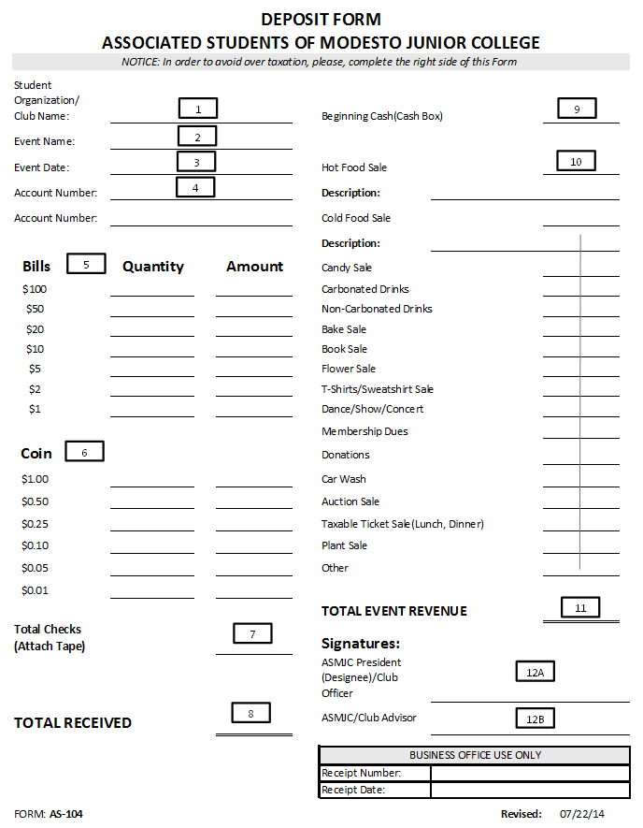
SAMPLE OF BANK OF AMERICA’S DROP SAFE REGISTER BAG

